% % ---------------------------------------------
% Name : Manan Vyas
% USCID: 7483-8632-00
% Email: mvyas@usc.edu
% EE519 : Speech Recognition : Final Exam : P3
% % ----------------------------------------------
% Setup
clc;
clear all;
close all;
Fs = 10000; % Hz - Sampling frq
load('final2014_p3.mat'); % we have normalized Speech signal here
n = length(speech);
% Apply a 25ms Hamming window ...
% 10k samples/sec => 25msec = 250 samples => Length of Hamming window
wLen = 250;
window = hamming(wLen);
% Take first 250 samples of the Speech signal
Speech = speech(1:250);
wSpeech = Speech.*window' ; % Windowed Speech
% Computing Cepstrum
wSpeechFFT = fft(wSpeech,1024); % 1024 point FFT of the windowed Speech
wSpeechFFT_log = log(abs(wSpeechFFT)); % Log Mag spectrum of the FFT
wSpeechFFT_cepstrum = real(ifft(wSpeechFFT_log,1024)); % Defintion of Cepstrum
% Part (A) All plots
figure;
subplot(3,1,1); plot(Speech); title('250 samples of original Speech sample');
xlabel('n ->'); ylabel('Speech');
subplot(3,1,2); plot(wSpeech);
title('Windowed version of above Speech signal using Hamming Window');
xlabel('n ->'); ylabel('s[n].W(hamming)[n]');
subplot(3,1,2); plot(wSpeech);
title('Windowed version of above Speech signal using Hamming Window');
xlabel('n ->'); ylabel('s[n].W(hamming)[n]');
subplot(3,1,3); plot(wSpeechFFT_cepstrum(1:200)); axis([1 200 -1 1.5]);
title('Real cepstrum');
xlabel('Quefrency ->'); ylabel('Real ceps amplitude');
% Part (B) : Pitch Estimation
%Liftering
wSpeechFFT_cepstrum_coEff = wSpeechFFT_cepstrum(1:length(wSpeechFFT_cepstrum));
L = zeros(1,length(wSpeechFFT_cepstrum_coEff));
% Liftering Window
L(20:140) = 1;
% Low time lifted cepstrum
yOp = real(wSpeechFFT_cepstrum_coEff.*L);
%Finding peak in lifted cepstrum
[peak_val,peak_loc] = max(yOp);
pitch_period = peak_loc;
pitch_frq = (1/pitch_period)*Fs;
% Part (C) : Uniform Quantizer
pitchMin = 50;
pitchMax = 300;
B = 7 ; % Bit precision size
% The quantized value of the pitch frequency using a 7bit uniform quantizer
quantPitchFrqValue = quant(pitch_frq,B,pitchMin,pitchMax)
quantValue = quant(pitch_frq,B,pitchMin,pitchMax);
% Part (D): Non uniform quantizer
% take the initial 28 co-efficients of the cepstrum co-eff
cepstrumCoEff28 = wSpeechFFT_cepstrum(1:28);
% Unifromly quantize these
for i=1:1:28
cepstrumCoEff28_UniQ(i) = quant(cepstrumCoEff28(i), 7, min(cepstrumCoEff28),max(cepstrumCoEff28));
end
figure
subplot(2,1,1)
plot(cepstrumCoEff28,'--r');
hold on
stem(cepstrumCoEff28_UniQ);
title('Uniformly Quantized initial 28 cepstrum co-effs');
xlabel('n ->'); ylabel('c[n]'); axis([1 28 min(cepstrumCoEff28_UniQ) max(cepstrumCoEff28_UniQ)]);
legend('Original Cepstrum Coeffs','Uniformly Quantized Cepstrum Coeff(7bit)');
hold off
% Non Uniform Quantization
cepstrumCoEff28_NonUniQ = nonUniformQuant(cepstrumCoEff28);
subplot(2,1,2)
plot(cepstrumCoEff28,'--r');
hold on
stem(cepstrumCoEff28_NonUniQ);
title('Non-Uniformly Quantized initial 28 cepstrum co-effs');
xlabel('n ->'); ylabel('_c[n]'); axis([1 28 min(cepstrumCoEff28_NonUniQ) max(cepstrumCoEff28_NonUniQ)]);
legend('Original Cepstrum Coeffs','Non-Uniformly Quantized Cepstrum Coeff');
hold off
% Part (E): Minimum phase reconstruction
% Right sided Cepstral Lifter
Lifter(1) = 1;
Lifter(2:28) = 2;
% Lifter the non uniformly quantized values
cepstrumCoEff28_UniQ_Liftered = cepstrumCoEff28_UniQ.*Lifter;
minimumPhaseRecostruction = fft(cepstrumCoEff28_UniQ_Liftered,1024);
% Part (F) : Sampled log magnitude and phase and signal reconstruction
figure
% We need to map the x-axis value to reflect frequency in Hz.
% To do that all you need to remember that the length of the
% FFT corresponds to the sampling rate Fs for continuous frequencies and
% corresponds to 2? for discrete frequency. Therefore
% to get the positive and negative frequencies
scale = -(1024/2):(1024/2-1);
subplot (2,1,1)
plot(scale*Fs/1024,fftshift(20*log10(abs(minimumPhaseRecostruction)))); % to get the frquency scale in Hz
title('Log Magnitude plot of minimum phase recosntruction');xlabel('f(Hz)->');ylabel('20*log|fft(Ceps,1024)| db scale');
subplot(2,1,2);
plot(scale*Fs/1024,fftshift((angle(minimumPhaseRecostruction))));
title('Phase plot of minimum phase recosntruction');xlabel('f(Hz)->');ylabel('<fft(Ceps,1024)');
% Now sample the log magnitude and phase values
toBeSampled = log(abs(minimumPhaseRecostruction));
diff = [5000,-ones(1,100)];
index = 1;
newHarms = 1;
for i=1:1:512 %because the spectrum FFT is symmetrical
index = index + 1;
newfreq = i*Fs/1024;
tempdiff = abs(quantValue - (i*Fs/(1024)));
diff(index) = quantValue - (i*Fs/(1024));
if(abs(diff(index)) > abs(diff(index-1)))
% sampledLogMag(i) = 20*log(abs(minimumPhaseRecostruction((quantValue+diff(index-1))*1024/(Fs*(i)))));
sampledLogMag(newHarms) = toBeSampled(i) ;%log(abs(minimumPhaseRecostruction(i)));
sampledPhase(newHarms) = angle(minimumPhaseRecostruction(i));
selectedHarmonicFrequencies(newHarms) = newfreq;
selectedHarmonicFrequenciesIndex(newHarms) = i;
quantValue = quantValue + quantPitchFrqValue;
newHarms = newHarms + 1;
diff = [5000,-ones(1,100)];
% i = 1;
if(i > 1024)
break;
end
index = 1;
end
end
selectedHarmonicFrequencies
selectedHarmonicFrequenciesIndex
sampledLogMag
sampledPhase
% Part (G) : Resynthesis
reconLogMag = exp(sampledLogMag);
reconPhase = exp(sampledPhase);
reconstructedSpeech = sinewave(reconLogMag,selectedHarmonicFrequencies,reconPhase,1000);
% Normalize
reconstructedSpeech = reconstructedSpeech./max(reconstructedSpeech) ;
figure
subplot(2,1,1)
plot(reconstructedSpeech); title('Reconstructed Speech'); xlabel('n ->'); ylabel('y[n]');
subplot(2,1,2);
plot(speech);title('Original Speech'); xlabel('n ->'); ylabel('x[n]');
% MSE Calculation
sqDiff = (double(reconstructedSpeech) - double(speech)).^2;
MSE = sum(sqDiff)/(length(reconstructedSpeech))

function [ quantValue ] = quant(inValue,B, minVal, maxVal)
% 7 bit quantizer on the input value 'inValue' by B bits
% minVal and maxVal denotes the minimum and maximum values of the input
% data :: quantValue
% Reference : http://www.mathworks.com/help/matlab/ref/bsxfun.html
% Reference : https://courses.engr.illinois.edu/ece420/lab3/prelab3.html
% Normalize such that the maxValue of the input comes in [-1 to 1] range
% divide by the smallest power of two such that the resulting absolute value of the largest number
% is less than or equal to one
% This is an easy but fairly reasonable approximation of how numbers
% outside the range of -1 to 1 are actually handled on the DSP.
N = nextpow2(maxVal-minVal);
inValue = inValue/(2^N);
% Next, quantize to B bits of precision by first multiplying them by 2^{B} rounding to the nearest integer
Qval = (round((inValue)*(2^(B))))/(2^(B));
% %Set up Quantization levels as a kind of lookup
% lvl = linspace(minVal,maxVal,2^B);
% % Level nearest to the quantized lookup -gives the index from the lookup
% [~,Idx] = min(abs(bsxfun(@minus,inValue,lvl.')));
% quantValue = inValue(Idx);
% Recover orginigal equivalent
quantValue = Qval*(2^N);
end
function [ out ] = nonUniformQuant( in )
% Custom non uniform Quantizer
% selects the bit depth of current co-efficient depending upon the dynamic
% range around its neighbours and the average dynamic range
% Since we have the pre-calculated co-efficients we can calculate average
% dynamic range of the whole set
sumDiff = 0;
for i=2:1:length(in)
diff = abs(in(i) - in(i-1));
sumDiff = sumDiff + diff;
end
avgDiff = sumDiff/(length(in)-1); % average dynamic range of the whole inp
% Max value of the array of co-effs
maxVal = max(in);
minVal = min(in);
% Based on the Local Dynamic range and the avg dynamic range make a
% decision to fix B
B(1) = 32;
out(1) = quant(in(1),B(1),minVal,maxVal);
for i=2:1:length(in)
if (abs(in(i)-in(i-1)) > 3*avgDiff)
B(i) = 64;
out(i) = quant(in(i),B(i),minVal,maxVal);
elseif (abs(in(i)-in(i-1)) > 2*avgDiff)
B(i) = 32;
out(i) = quant(in(i),B(i),minVal,maxVal);
elseif (abs(in(i)-in(i-1)) > avgDiff)
B(i) = 16;
out(i) = quant(in(i),B(i),minVal,maxVal);
else
B(i) = 8;
out(i) = quant(in(i),B(i),minVal,maxVal);
end
end

quantPitchFrqValue = 122 (Hz)

selectedHarmonicFrequencies (Hz) =
1.0e+03 *
Columns 1 through 7
0.1270 0.2539 0.3711 0.4980 0.6152 0.7422 0.8594
Columns 8 through 14
0.9863 1.1035 1.2305 1.3477 1.4746 1.5918 1.7188
Columns 15 through 21
1.8359 1.9629 2.0801 2.2070 2.3242 2.4512 2.5684
Columns 22 through 28
2.6953 2.8125 2.9395 3.0566 3.1836 3.3008 3.4277
Columns 29 through 35
3.5449 3.6719 3.7891 3.9160 4.0332 4.1602 4.2773
Columns 36 through 40
4.4043 4.5215 4.6484 4.7656 4.8926
selectedHarmonicFrequenciesIndex =
Columns 1 through 13
13 26 38 51 63 76 88 101 113 126 138 151 163
Columns 14 through 26
176 188 201 213 226 238 251 263 276 288 301 313 326
Columns 27 through 39
338 351 363 376 388 401 413 426 438 451 463 476 488
Column 40
501
sampledLogMag =
Columns 1 through 7
-0.0430 0.1008 -0.0405 0.4758 0.8666 0.9158 0.7047
Columns 8 through 14
0.5885 0.8005 1.0298 1.1696 1.2122 1.1389 0.9593
Columns 15 through 21
0.7074 0.4022 0.1664 -0.2376 0.1562 0.6689 0.7955
Columns 22 through 28
0.9662 1.2272 1.3150 1.2105 1.1228 1.1680 1.3126
Columns 29 through 35
1.4602 1.4511 1.3502 1.4879 1.6208 1.5687 1.5242
Columns 36 through 40
1.5419 1.4171 1.3465 1.5151 1.5435
sampledPhase =
Columns 1 through 7
1.4426 0.4545 0.2507 0.2163 -0.2908 -0.8790 -1.1968
Columns 8 through 14
-1.1372 -1.1372 -1.3343 -1.5987 -1.9301 -2.2208 -2.4749
Columns 15 through 21
-2.6211 -2.6105 -2.5213 -2.1442 -1.4671 -1.5560 -1.6892
Columns 22 through 28
-1.6638 -1.8015 -2.0915 -2.2577 -2.2352 -2.1803 -2.1718
Columns 29 through 35
-2.2993 -2.5007 -2.5071 -2.4501 -2.6215 -2.8080 -2.8473
Columns 36 through 40
-2.9579 -3.0591 -2.9238 -2.9294 -3.1028
MSE = 0.0943
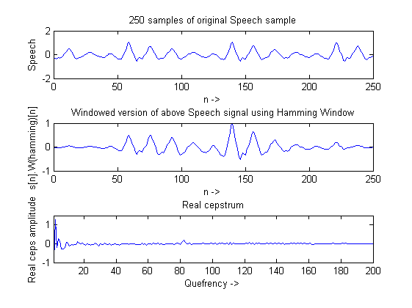
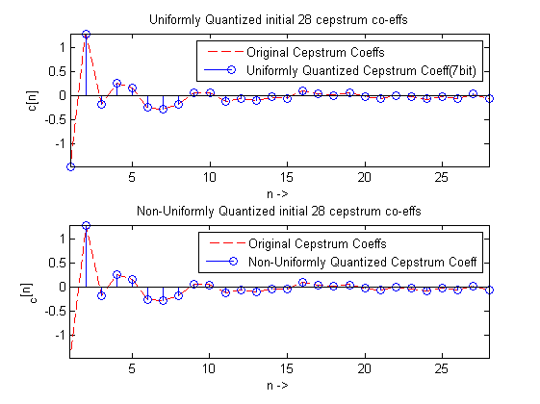
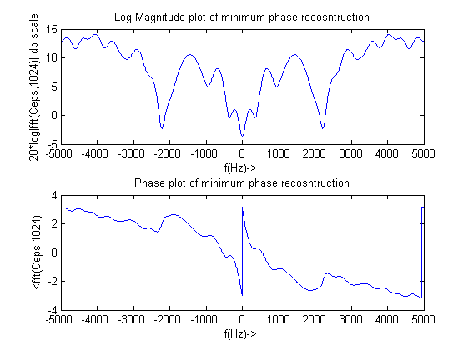
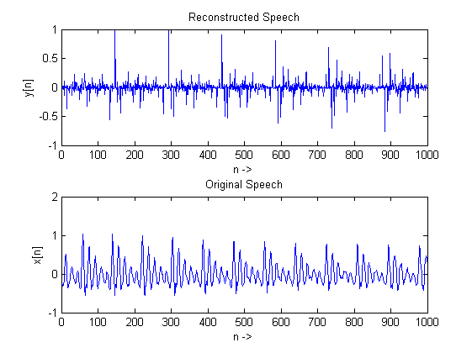
Published with MATLAB® R2013a

